ArjunaXTS 1.0 for JBoss 3.2.0
User Guide



ArjunaXTS-AAUG–11/8/26

Legal Notices
The information contained in this documentation is subject to change without notice.
Arjuna Technologies Ltd makes no warranty of any kind with regard to this material, including, but not limited to, the implied warranties of merchantability and fitness for a particular purpose. Arjuna Technologies Ltd shall not be liable for errors contained herein or for incidental or consequential damages in connection with the furnishing, performance, or use of this material.
Java™ and J2EE is a U.S. trademark of Sun Microsystems, Inc. Microsoft® and Windows NT® are registered trademarks of Microsoft Corporation. Oracle® is a registered U.S. trademark and Oracle9™, Oracle9 Server™ Oracle9 Enterprise Edition™ are trademarks of Oracle Corporation. Unix is used here as a generic term covering all versions of the UNIX® operating system. UNIX is a registered trademark in the United States and other countries, licensed exclusively through X/Open Company Limited.
Software Version
ArjunaXTS 1.0
Restricted Rights Legend
Use, duplication, or disclosure is subject to restrictions as set forth in contract subdivision (c)(1)(ii) of the Rights in Technical Data and Computer Software clause 52.227-FAR14.
Arjuna Technologies Ltd
Nanotechnology Centre
Herschel Building
Newcastle upon Tyne
NE1 7RU
United Kingdom
© Copyright 2003 Arjuna Technologies Ltd

Table of Contents
ArjunaXTS 1.0 for JBoss 3.2.0 33
ArjunaXTS-AAUG–4/9/03 33
Table of Contents iii
Table of Figures v
Preface vii
About This Guide vii
Introduction vii
Who Should Read This Guide vii
What You Should Know vii
Additional Documentation vii
Documentation Conventions ix
The Arjuna Web Site ix
Arjuna Technical Support x
The AXTS Web Site x
1. Introduction 11
AXTS Overview 11
Managing Service-Based Processes 12
Servlets 12
SOAP 13
WSDL 13
Transactions Overview 13
The Coordinator 14
The Transaction Context 15
ACID Transactions 15
Two-Phase Commit 16
A New Transaction Protocol 17
WS-C and WS-T Overview 17
Coordination 18
WS-Transaction 21
Atomic Transactions (AT) 24
Application Messages 28
WS-C/T Messages 29
Summary 29
2. Getting Started 30
Introduction 30
Installing the ArjunaXTS Software 30
Basic Concepts 30
The Transaction Manager 30
Deployment descriptors 32
Creating and Deploying Participants 32
Creating Client Applications 32
Hints and tips 33
Summary 33
3. Transactional Web Services 35
Introduction 35
A Transactional Web Service 35
4. Participants 39
Introduction 39
The Participant: An Overview 39
PhaseZeroParticipant 40
TwoPCParticipant 40
OutcomeNotificationParticipant 40
Participant Creation and Deployment 41
Implementing Participants 41
Deploying Participants 41
5. The ArjunaXTS API 43
Introduction 43
AXTS API 43
Vote 43
TxContext 44
UserTransaction 44
UserTransactionFactory 45
TransactionManager 45
TransactionFactory 46

Table of Figures
Figure 1-1 Web Services and ArjunaXTS 14
Figure 1-2 Web Services and Context Flow 15
Figure 1-3 The Two-Phase Commit Protocol 16
Figure 1-4 WS-C architecture 18
Figure 1-5 WS-C infrastructure 19
Figure 1-6 Activation Service WSDL Interfaces 20
Figure 1-7 Registration Service WSDL Interface 20
Figure 1-8 WS-Coordination and WS-Transaction 21
Figure 1-9 WS-Transaction Global View 22
Figure 1-10 Transactional Service and Participant 23
Figure 1-11 Two-Phase Commit State Transitions 26
Figure 1-12 The AT Model 26
Figure 2-1 The client-config.wsdd File 33
Figure 3-1 Context Handlers Registered with the SOAP Server 36
Figure 3-2 General Pattern for Back-End Integration, Service Side 36
Figure 4-1 Transactions, Participants, and Back-End Transaction Control 39
Figure 5-1 API Example Showing Participant Voting 44

Preface

About This Guide

Introduction
The ArjunaXTS (AXTS) Users’ Guide provides information on how to develop service-based applications that use transaction technology to manage business processes. AXTS provides a means of interacting with Web services within transactions, and constructing transaction-aware Web services, according to the WS-C and WS-T specifications, using common Web services platforms. While this guide discusses many of Web services standards like SOAP, WSDL and UDDI, it does not attempt to address all of their fundamental constructs. However, basic concepts are provided where necessary.

Who Should Read This Guide
This guide is most relevant for application developers and Web service developers who are interested in building applications and Web services that are transaction-aware. This guide is also useful for system analysts and project managers that are unfamiliar with transactions as they pertain to Web services.

What You Should Know
AXTS uses the Java programming language and this manual assumes that you are familiar with programming in Java. In addition, a fundamental level of understanding in the following areas will also be useful:
- A Working knowledge of Web services, including XML, SOAP, WSDL, and UDDI;
- A general understanding of transactions;
- A general understanding of WS-C and WS-T;
Note: This guide presents overview information for all of the above technologies and may provide additional detailed information. In particular, the WS-C and WS-T specifications are discussed in great detail.

Additional Documentation
In addition to the AXTS User's Guide, the following guides are available:
Document | Description
AXTS Installation Guide | This guide contains detailed step-by-step instructions for installing AXTS.
AXTS Release Notes | This document provides information about new features, fixed features, upgrading, and known issues.
Table 0-1 Additional Manuals for ArjunaXTS
AXTS introduces a number of new concepts. For this reason, some terms used in this documentation may be unfamiliar to even the most knowledgeable users.
To make the information in this document as clear and understandable as possible, a Glossary has been included. The first instance of terms that are defined in this Glossary appear in a bold, italic typeface within the text. Subsequent occurrences of the term appear in plain typeface, as follows:
“A Transaction Identifier is a globally unique identifier assigned to a transaction. All participants in a transaction receive an identifier.”
This example indicates that the term “Transaction Identifier” is defined within the Glossary and that the reader should reference that definition if they are unsure of exactly what an atom identifier is.

Documentation Conventions
The following conventions are used in this guide:

Convention | Description
Bold | Used to identify menu selections, toolbar selections, and section references.
Italic | In paragraph text, italic identifies the titles of documents that are being referenced. When used in conjunction with the Code text described below, italics identify a variable that should be replaced by the user with an actual value.
Bold Italic | Used to identify a term that is defined in the Glossary in Appendix A. Readers should reference the Glossary when they are unsure of the complete meaning of a term. Only the first instance of a Glossary term appears in bold, italic text. Subsequent instances appear in plain type.
monospace text | Text that represents programming code.
monospace italic text | Variables in programming code.
CTRL+X | A combination of keystrokes that are pressed simultaneously.
Function | Function | A path to a function or dialog box within an interface. For example, “Select File | Open” indicates that you should select the Open function from the File menu.
( ) and | | Parentheses enclose optional items in command syntax. The vertical bar separates syntax items in a list of choices. For example, any of the following four items can be entered in this syntax:  persistPolicy (Never | OnTimer | OnUpdate | NoMoreOftenThan)
Note and Caution | A note highlights important supplemental information.  A caution highlights procedures or information that is necessary to avoid damage to equipment, damage to software, loss of data, or invalid test results.

The Arjuna Web Site
The starting point for all of Arjuna’s customer support and training is our Web site. Visit it at http://www.arjuna.com/ for information and support, including:
- LISTSERV Support;
- Add-ons and Patches;
- Demos;
- Product Evaluation Support;
- Training.

Arjuna Technical Support
If you need specific, immediate assistance or would like to send us your feedback, contact our Technical Support team.
Email: support@arjuna.com

The AXTS Web Site
The AXTS Web site contains additional information on AXTS, WS-C and WS-T. It also offers a number of presentations and technical papers on WS-C, WS-T and AXTS, and highlights industry events where members of the AXTS team will be speaking. See: http://www.arjuna.com/axts/

Introduction
ArjunaXTS (AXTS) supports the coordination of private and public Web services in a business transaction. Therefore, to understand AXTS, you must be familiar with Web services, and also understand a little about transactions. This chapter introduces AXTS and provides a brief overview of the technologies that form the Web services standard. Additionally, this chapter explores some of the fundamentals of transactioning technology and how it can be applied to Web services. Much of the content presented in this chapter is detailed throughout this guide; however, only overview information about Web services is provided. If you are new to creating Web services, please see consult your Web services platform documentation.

AXTS Overview
AXTS is a transaction solution for Web services. Using AXTS, business partners can coordinate complex business transactions in a controlled and reliable manner. The AXTS API supports a transactional coordination model based on the WS-C and WS-T specifications. WS-C is a generic coordination framework developed by IBM, Microsoft and BEA, and WS-T is a transaction protocol that utilizes this framework. Both specifications are available from http://www.ibm.com/developerworks/library/.
Web services are modular, reusable software components that are created by exposing business functionality through a Web service interface. Web services communicate directly with other Web services using standards-based technologies such as SOAP and HTTP. These standards-based communication technologies allow Web services to be accessed by customers, suppliers, and trading partners, independent of hardware operation system or programming environment. The result is a vastly improved collaboration environment as compared to today's EDI and B2B solutions—an environment where businesses can expose their current and future business applications as Web services that can be easily discovered and accessed by external partners.
Web services, by themselves, are not fault tolerant. In fact, some of the reasons that make it an attractive development solution are also the same reasons that service-based applications may have drawbacks:
- Application components that are exposed as Web services may be owned by third parties, which provides benefits in terms of cost of maintenance, but drawbacks in terms of having exclusive control over their behavior;
- Web services are usually remotely located which increases risk of failure due to increased network travel for invocations.
Applications that have high dependability requirements, must find a method of minimizing the effects of errors that may occur when an application consumes Web services. One method of safeguarding against such failures is to interact with an application’s Web services within the context of a transaction. A transaction is simply a unit of work which is completed entirely, or in the case of failures is reversed to some agreed consistent state – normally to appear as if the work had never occurred in the first place. With AXTS, transactions can span multiple Web services which means that work performed across multiple enterprises can be managed with transactional support.

Managing Service-Based Processes
AXTS allows you to create transactions that drive complex business processes spanning multiple Web services. Current Web services standards do not address the requirements for a high-level coordination of services since in today’s Web services applications, which use single request/receive interactions, coordination is typically not a problem. However, for applications that engage multiple services among multiple business partners, coordinating and controlling the resulting interactions is essential. This becomes even more apparent when we realize that we generally have little in the way of formal guarantees when interacting with third-party Web services.
AXTS provides the infrastructure for coordinating services during a business process. By organizing processes as transactions, business partners can collaborate on complex business interactions in a reliable manner, insuring the integrity of their data - usually represented by multiple changes to a database – but without the usual overheads and drawbacks of directly exposing traditional transaction-processing engines directly onto the web. The following example demonstrates how an application may manage service-based processes as transactions:
The application in question allows a user to plan a social evening. This application is responsible for reserving a table at a restaurant, and reserving tickets to a show. Both activities are paid for using a credit card. In this example, each service represents exposed Web services provided by different service providers. AXTS is used to envelop the interactions between the theater and restaurant services into a single (potentially) long-running business transaction. The business transaction must insure that seats are reserved both at the restaurant and the theater. If one event fails the user has the ability to decline both events, thus returning both services back to their original state. If both events are successful, the user’s credit card is charged and both seats are booked. As you may expect, the interaction between the services must be controlled in a reliable manner over a period of time. In addition, management must span several third-party services that are remotely deployed.
Without the backing of a transaction, an undesirable outcome may occur. For example, the user credit card may be charged, even though one or both of the bookings may have failed.
This simple example describes the situations where AXTS excels at supporting business processes across multiple enterprises. This example is further refined throughout this guide, and appears as a standard demonstrator (including source code) with the AXTS distribution.

Servlets
As we shall see later, the WS-C and WS-T protocols are based on one-way interactions of entities rather than traditional synchronous request/response RPC style interactions. Entities (e.g., transaction participants) invoke operations on other entities (e.g., the transaction coordinator) in order to return responses to requests. What this means is that the programming model is based on peer-to-peer relationships. What this means to the underlying implementation platform is that all services, whether they are participants, coordinators or clients, must have an active component that allows them to receive unsolicited messages.
In the current implementation of AXTS, the active component is achieved through the use of Java servlet technology. Each endpoint that can be communicated with via SOAP/XML is represented as a servlet (and published within JNDI). Fortunately for the developer, this use of servlets occurs transparently. The only drawback is that (currently) clients must reside within a domain capable of hosting servlets, i.e., an application server. It is our intention that future versions of ArjunaXTS will provide configurable deployment options, allowing servlets where required, but not mandating them.

SOAP
SOAP has emerged as the de-facto message format for XML-based communication in the Web services arena. It is a lightweight protocol that allows the user to define the content of a message and to provide hints as to how recipients should process that message.
SOAP messages can be divided into two main categories: Remote Procedure Call (RPC) and Document Exchange (DE). The primary difference between the two categories is that the SOAP specification defines encoding rules and conventions for RPC. The document exchange model allows the exchange of arbitrary XML documents - a key ingredient of business-to-business (B2B) document exchange. ArjunaXTS is based on the loosely coupled document-exchange style, yet it can support transactions spanning Web service that use either document-exchange or RPC.

WSDL
WSDL (Web services Description Language) is an XML-based language used to define Web service interfaces. An application that consumes a Web service parses the service’s WSDL document to discover the location of the service, the operations that the service supports, the protocol bindings the service supports (SOAP, HTTP, etc), and how to access them (for each operation, WSDL describes the format that the client must follow).

Transactions Overview
Transactions have emerged as the dominant paradigm for coordinating interactions between parties in a distributed system, and in particular to manage applications that require concurrent access to shared data. Much of AXTS API is based on contemporary transaction APIs whose familiarity will enhance developer productivity and lessen the learning curve. While the following section provides the essential information that you should know before starting to use AXTS, it should not be treated as a definitive reference to all transactional technology.
A classic transaction is a unit of work which either completely succeeds, or fails with all partially completed work being undone. When a transaction is committed, all changes made by the associated requests are made durable, normally by committing the results of the work to a database. If a transaction should fail and is rolled back, all changes made by the associated work are undone. Transactions in distributed systems typically require the use of a transaction manager that is responsible for coordinating all of the participants that are part of the transaction.
The main components involved in using and defining ArjunaXTS are illustrated in Figure 1-1.
- A Transaction Service: The Transaction Service captures the model of the underlying transaction protocol and coordinates parties affiliated with the transaction according to that model.
- A Transaction API: Provides an interface for transaction demarcation and the registration of participants.
- A Participant: The entity which cooperates with the transaction service on behalf of its associated business logic.
- The Context: Captures the necessary details of the transaction such that participants can enlist within its scope.
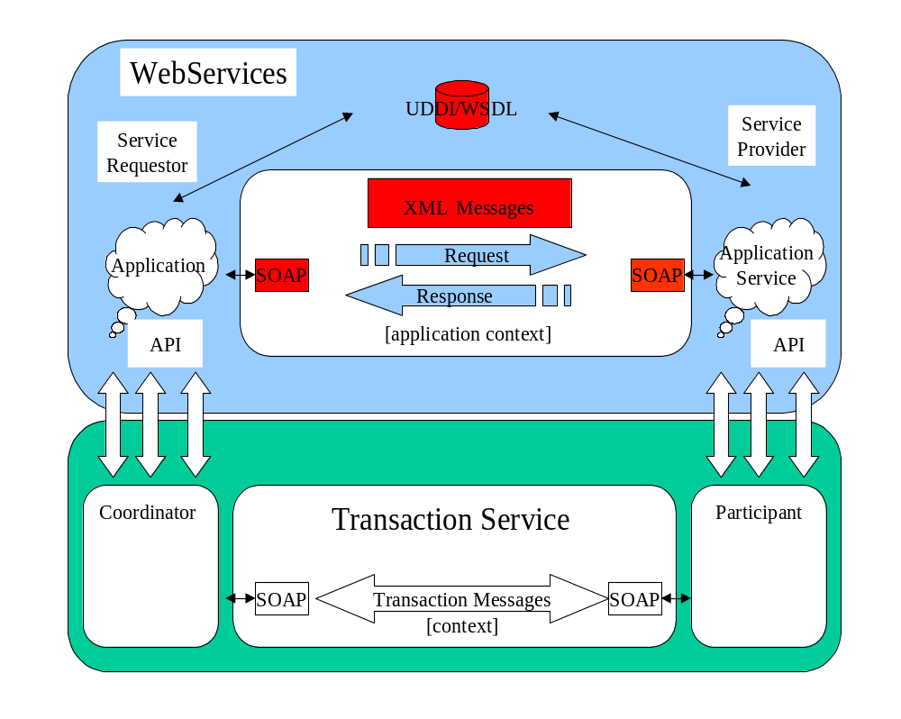
Figure 1-1 Web Services and ArjunaXTS

The Coordinator
Associated with every transaction is a coordinator, which is responsible for governing the outcome of the transaction. The coordinator may be implemented as a separate service or may be co-located with the user for improved performance. Each coordinator is created by the transaction manager service, which is in effect a factory for those coordinators.
A coordinator communicates with enrolled participants to inform them of the desired termination requirements, i.e., whether they should accept (e.g., confirm) or reject (e.g., cancel) the work done within the scope of the given transaction. For example, whether to purchase the (provisionally reserved) flight tickets for the user or to release them. An application/client may wish to terminate a transaction in a number of different ways (e.g., confirm or cancel). However, although the coordinator will attempt to terminate in a manner consistent with that desired by the client, it is ultimately the interactions between the coordinator and the participants that will determine the actual final outcome.
A transaction manager is typically responsible for managing coordinators for many transactions. The initiator of the transaction (e.g., the client) communicates with a transaction manager and asks it to start a new transaction and associate a coordinator with the transaction. Once created, the context can be propagated to Web services in order for them to associate their work with the transaction.

The Transaction Context
In order for a transaction to span a number of services, certain information has to be shared between those services in order to propagate information about the transaction. This information is known as the Context. Using AXTS, the context is automatically propagated and processed by transaction-aware components of an application. Though AXTS removes most of the work associated with propagating contexts, it is still instructive to understand what information is captured in a context:
- A transaction identifier which guarantees global uniqueness for an individual transaction;
- The transaction coordinator location or endpoint address so participants can be enrolled.
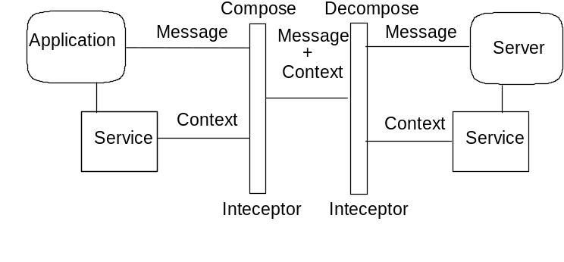
Figure 1-2 Web Services and Context Flow
Whenever an application message is sent, the AXTS Client API automatically creates a context and embeds it into the message. Similarly, any transaction-aware services are able to extract that context using the AXTS service-side infrastructure and use it to perform work within the context of a particular transaction – even though that transaction was initiated elsewhere on the Web! The value of this approach is that the business logic contained within the client application and services are not peppered with transaction-processing code.

ACID Transactions
Traditionally, transaction processing systems support ACID properties. ACID is an acronym for Atomic, Consistent, Isolated, and Durable. A unit of work has traditionally been considered transactional only if the ACID properties are maintained:
- Atomicity: The transaction executes completely or not at all.
- Consistency: The effects of the transaction preserves the internal consistency of an underlying data structure.
- Isolated: The transaction runs as if it were running alone with no other transactions running and is not visible to other transactions.
- Durable: the transaction’s results will not be lost in the event of a failure.

Two-Phase Commit
The classical two-phase commit approach is the bedrock of AXTS (and more generally of WS-T). Two-phase commit provides coordination of parties that are involved in a transaction. In general, the flow of a two-phase commit transaction is as follows:
- A transaction is started, and some work is performed.
- Once the work is finished, the two-phase commit begins.
- The coordinator (transaction manager) of the transaction asks each resource taking part in the transaction whether it is prepared to commit.
- If all resources respond positively, the coordinator instructs all work performed to be made durable (usually committed to a database).
- If not, all work performed is rolled back (undone) such that the underlying data structures are in their original states.
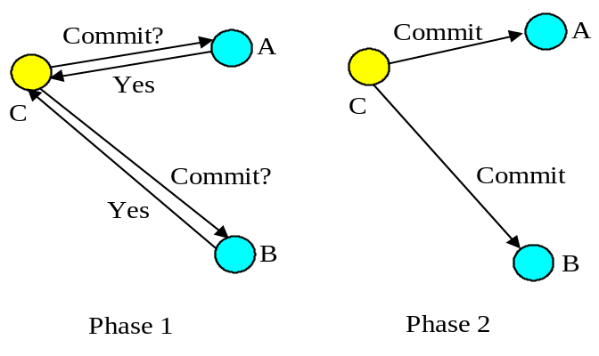
Figure 1-3 The Two-Phase Commit Protocol
Note: During two-phase commit transactions, coordinators and resources keep track of activity in non-volatile data stores so that they can recover in the case of a failure.

A New Transaction Protocol
Many component technologies offer mechanisms for coordinating ACID transactions based on two-phase commit semantics (i.e., CORBA/OTS, JTS/JTA, MTS/MSDTC). ACID transactions are not suitable for all Web services transactions since:
- Classic ACID transactions are predicated on the idea that an organization that develops and deploys applications does so on their own infrastructure, typically an Intranet. Ownership meant transactions operated in a trusted and predictable manner. To assure ACIDity, potentially long-lived locks could be kept on underlying data structures during two-phase commit. Resources could be used for any period of time and released when the transaction was complete. In the Web services arena, these assumptions are no longer valid. One obvious reason is that the owners of data exposed through a Web service will refuse to allow their data to be locked for extended periods since to allow such locks invites denial-of-service.
- Since all application infrastructure is generally owned by a single party, systems using classical ACID transactions normally assume that participants in a transaction will obey the will of the transaction manager and only infrequently decide to make unilateral decisions which will hamper other participants in a transaction. On the contrary, Web services participating in a transaction can effectively decide to resign from the transaction at any time, and the consumer of the service generally has little in the way of quality of service guarantees to prevent this.

Addressing the Problems of Transactioning in Loosely Coupled Systems
Though extended transaction models which relax the ACID properties have been proposed over the years, to implement these concepts for the Web services architecture WS-T provides a new transaction protocol. AXTS is designed to accommodate four underlying requirements inherent in any loosely coupled architecture like Web services:
- Ability to handle multiple successful outcomes to a transaction, with the ability to involve operations whose effects may not be isolated or durable;
- Coordination of autonomous parties whose relationships are governed by contracts rather than the dictates of a central design authority;
- Discontinuous service, where parties are anticipated to suffer outages during their lifetime, and coordinated work must be able to survive such outages;
- Interoperation using XML over multiple communication protocols – AXTS chooses to use SOAP encoding carried over HTTP for the first release and other SOAP-friendly transports for future releases.

WS-C and WS-T Overview
This section provides fundamental concepts associated with WS-C/T. All of these concepts are defined in the WS-C/T specifications. WS-C/T principles are discussed throughout this guide.
Note, if you are well versed in the WS-C and WS-T specifications then you may want to just skim through this part of the manual.

Coordination
In general terms, coordination is the act of one entity (the known as the coordinator) disseminating information to a number of participants for some domain-specific reason. This reason could be in order to reach consensus on a decision like in a distributed transaction protocol, or simply to guarantee that all participants obtain a specific message, as occurs in a reliable multicast environment. When parties are being coordinated, information known as the coordination context is propagated to tie together operations which are logically part of the same coordinated work or activity. This context information may flow with normal application messages, or may be an explicit part of a message exchange and is specific to the type of coordination being performed.
The fundamental idea underpinning WS-Coordination is that there is a generic need for a coordination infrastructure in a Web services environment. The WS-Coordination specification defines a framework that allows different coordination protocols to be plugged-in to coordinate work between clients, services and participants, as shown in Figure 1-4.
The WS-Coordination specification talks in terms of activities, which are distributed units of work, involving one or more parties (which may be services, components, or even objects). At this level, an activity is minimally specified and is simply created, made to run, and then completed.
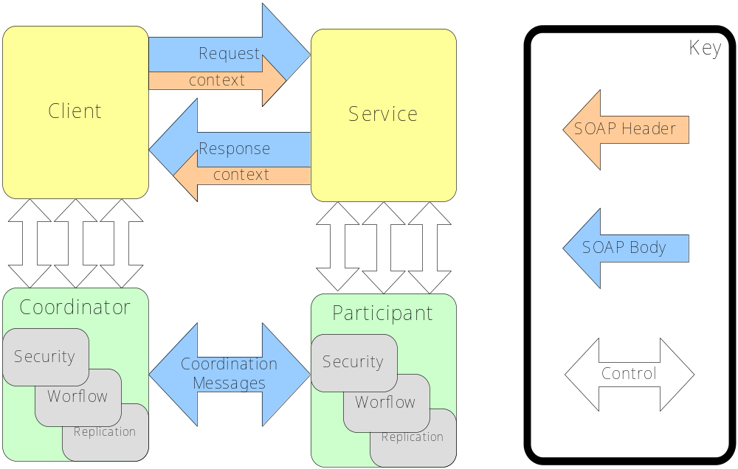
Figure 1-4 WS-C architecture
Whatever coordination protocol is used, and in whatever domain it is deployed, the same generic requirements are present:
- Instantiation (or activation) of a new coordinator for the specific coordination protocol, for a particular application instance;
- Registration of participants with the coordinator, such that they will receive that coordinator’s protocol messages during (some part of) the application’s lifetime;
- Propagation of contextual information between Web services that comprise the application;
- An entity to drive the coordination protocol through to completion.
The first three of these points are directly the concern of WS-Coordination while the fourth is the responsibility of a third-party entity, usually the client application that controls the application as a whole. These four WS-Coordination roles and their interrelationships are shown in Figure 1-5.
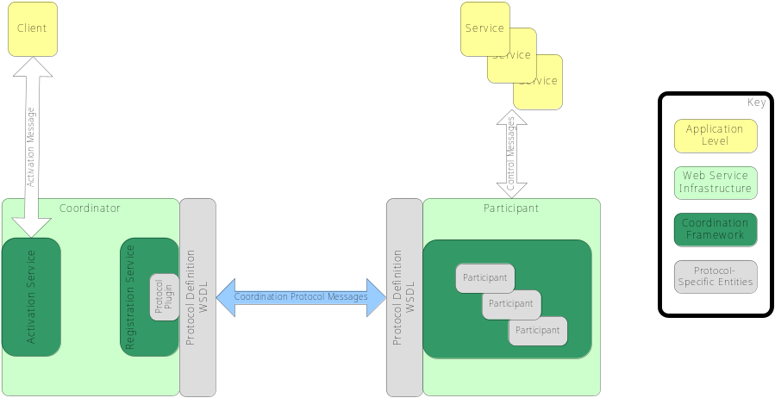
Figure 1-5 WS-C infrastructure

Activation
The WS-Coordination framework exposes an Activation Service which supports the creation of coordinators for specific protocols and their associated contexts. The process of invoking an activation service is done asynchronously, and so the specification defines both the interface of the activation service itself, and that of the invoking service, so that the activation service can call back to deliver the results of the activation – namely a context that identifies the protocol type and coordinator location. These interfaces are presented in Figure 1-6, where the activation service has a one-way operation that expects to receive a CreateCoordinationContext message and correspondingly the service that sent the CreateCoordinationContext message expects to be called back with a CreateCoordinationContextResponse message, or informed of a problem via an Error message.
<!-- Activation Service portType Declaration -->
<wsdl:portType name="ActivationCoordinatorPortType">
<wsdl:operation name="CreateCoordinationContext">
<wsdl:input
message="wscoor:CreateCoordinationContext"/>
</wsdl:operation>
</wsdl:portType>

<!-- Activation Requester portType Declaration -->
<wsdl:portType name="ActivationRequesterPortType">
<wsdl:operation
name="CreateCoordinationContextResponse">
<wsdl:input
message="wscoor:CreateCoordinationContextResponse"/>
</wsdl:operation>
<wsdl:operation name="Error">
<wsdl:input message="wscoor:Error"/>
</wsdl:operation>
</wsdl:portType>
Figure 1-6 Activation Service WSDL Interfaces

Registration
Once a coordinator has been instantiated and a corresponding context created by the activation service, a Registration Service is created and exposed. This service allows participants to register to receive protocol messages associated with a particular coordinator. Like the activation service, the registration service assumes asynchronous communication and so specifies WSDL for both registration service and registration requester, as shown in Figure 1-7.
<!-- Registration Service portType Declaration -->
<wsdl:portType name="RegistrationCoordinatorPortType">
<wsdl:operation name="Register">
<wsdl:input message="wscoor:Register"/>
</wsdl:operation>
</wsdl:portType>

<!-- Registration Requester portType Declaration -->
<wsdl:portType name="RegistrationRequesterPortType">
<wsdl:operation name="RegisterResponse">
<wsdl:input message="wscoor:RegisterResponse"/>
</wsdl:operation>
<wsdl:operation name="Error">
<wsdl:input message="wscoor:Error"/>
</wsdl:operation>
</wsdl:portType>
Figure 1-7 Registration Service WSDL Interface
When a participant is registered with a coordinator through the registration service, it receives messages that the coordinator sends (for example, “prepare to complete” and “complete” messages if a two-phase protocol is used); where the coordinator’s protocol supports it, participants can also send messages back to the coordinator.

Completion
The role of terminator is generally played by the client application, which at an appropriate point will ask the coordinator to perform its particular coordination function with any registered participants – to drive to protocol through to its completion. On completion, the client application may be informed of an outcome for the activity which may vary from simple succeeded/failed notification through to complex structured data detailing the activity’s status.

WS-Transaction
In the past, making traditional transaction systems talk to one another was a holy grail that was rarely achieved. With the advent of Web services, we have an opportunity to leverage an unparalleled interoperability technology to splice together existing transaction processing systems that already form the backbone of enterprise level applications.

WS-Coordination Foundations
An important aspect of WS-Transaction that differentiates it from traditional transaction protocols is that a synchronous request/response model is not assumed. This model derives from the fact that WS-Transaction is, as we see in Figure 1-8, layered upon the WS-Coordination protocol whose own communication patterns are asynchronous by default.
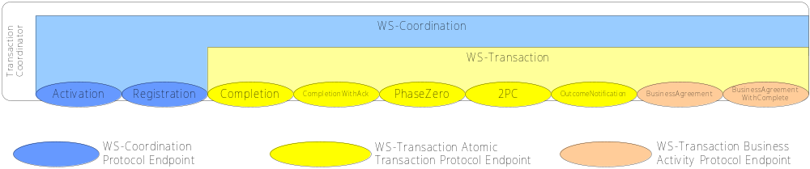
Figure 1-8 WS-Coordination and WS-Transaction
We saw in the previous article on Web Services Coordination how it provides a generic framework for specific coordination protocols, like WS-Transaction, to be plugged in. Recall that WS-Coordination provides only context management – it allows contexts to be created and activities to be registered with those contexts. WS-Transaction leverages the context management framework provided by WS-Coordination in two ways. Firstly it extends the WS-Coordination context to create a transaction context. Secondly, it augments the activation and registration services with a number of additional services (Completion, CompletionWithAck, PhaseZero, 2PC, OutcomeNotification, BusinessAgreement, and BusinessAgreementWithComplete) and two protocol message sets (one for each of the transaction models supported in WS-Transaction) to build a fully-fledged transaction coordinator on top the WS-Coordination protocol infrastructure.

WS-Transaction Architecture
WS-Transaction supports the notion of the service and participant as distinct roles, making the distinction between a transaction-aware service and the participants that act on behalf of the service during a transaction: transactional services deal with business-level protocols, while the participants handle the underlying WS-Transaction protocols, as shown in Figure 1-9.
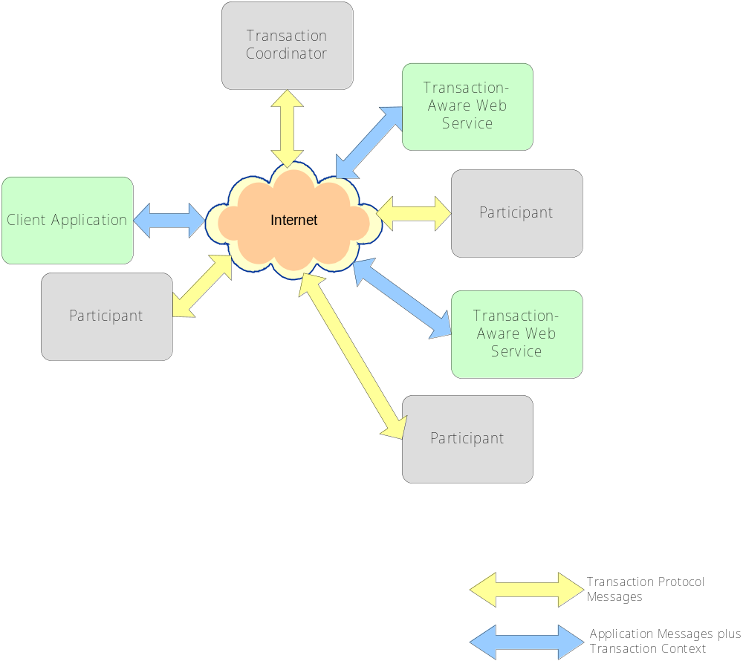
Figure 1-9 WS-Transaction Global View
A transaction-aware service encapsulates the business logic or work that is required to be conducted within the scope of a transaction. This work cannot be confirmed by the application unless the transaction also commits and so control is ultimately removed from the application and placed into the transaction’s domain.
The participant is the entity that, under the dictates of the transaction coordinator, controls the outcome of the work performed by the transaction-aware Web service. In Figure 1-9 each service is shown with one associated participant that manages the transaction protocol messages on behalf of its service, while in Figure 1-10, we see a close-up view of a single service, and a client application with their associated participants.
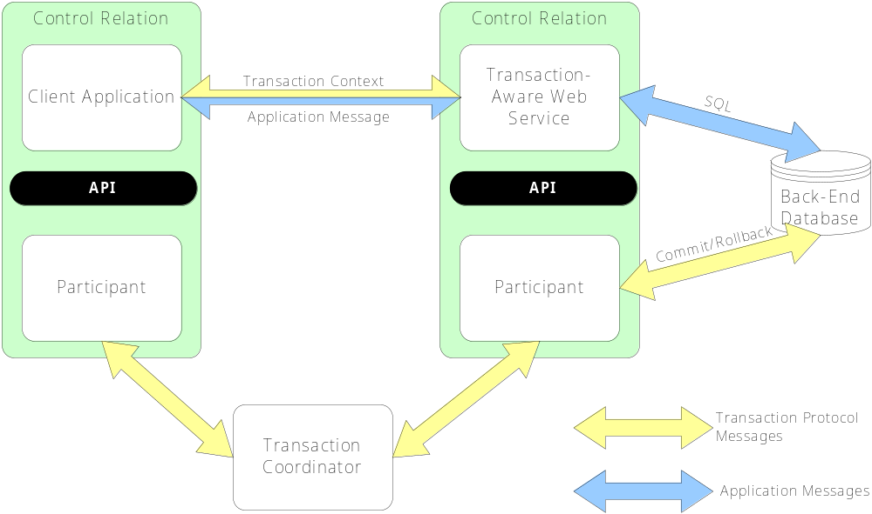
Figure 1-10 Transactional Service and Participant
The transaction aware Web service and its participant both serve a shared transactional resource, and there is a control relationship between them through some API - which on the Java platform is JAXTX. In the example shown in Figure 1-10, we assume that the database is accessed through a transactional JDBC database driver, where SQL statements are sent to the database for processing via that driver, but where those statements will be tentative and only commit if the transaction does. In order to do this, the driver/database will associate a participant with the transaction which will inform the database of the transaction outcome. Since all transactional invocations on the Web service carry a transaction context, the participant working with the database is able to identify the work that the transactional service did within the scope of a specific transaction and either commit or rollback the work.
At the client end, things are less complex. Through its API, the client application registers a participant with the transaction through which it controls transaction termination.

WS-Transaction Models
Given that we have already seen that traditional transaction models are not appropriate for Web services, we must pose the question, “what type of model or protocol is appropriate?” The answer to that question is that that no one specific protocol is likely to be sufficient, given the wide range of situations that Web service transactions are likely to be deployed within. Hence the WS-Transaction specification proposes two distinct models, where each supports the semantics of a particular kind of B2B interaction. In the following sections we shall discuss these two WS-Transaction models, but for the sake of brevity we ignore possible failure cases.
Note, as with WS-Coordination, the two WS-Transaction models are extensible allowing implementations to tailor the protocols as they see fit (e.g., to suit their deployment environments). For clarity, in the rest of this paper we shall discuss only the “vanilla” protocols and leave proprietary extensions out of the picture..

Atomic Transactions (AT)
An atomic transaction or AT is similar to traditional ACID transactions and intended to support short-duration interactions where ACID semantics are appropriate. Within the scope of an AT, services typically enroll transaction-aware resources, such as databases and message queues, indirectly as participants under the control of the transaction. When the transaction terminates, the outcome decision of the AT is then propagated to each enlisted resource via the participant, and the appropriate commit or rollback actions are taken by each.
This protocol is very similar to those employed by traditional transaction systems that already form the backbone of an enterprise. It is assumed that all services (and associated participants) provide ACID semantics and that any use of atomic transactions occurs in environments and situations where this is appropriate: in a trusted domain, over short durations.
To begin an atomic transaction, the client application firstly locates a WS-Coordination coordinator Web service that supports WS-Transaction. Once located, the client sends a WS-Coordination CreateCoordinationContext message to the activation service specifying http://schemas.xmlsoap.org/ws/2002/08/wstx as its coordination type and will get back an appropriate WS-Transaction context from the activation service. The response to the CreateCoordinationContext message, the transaction context, has its CoordinationType element set to the WS-Transaction AT namespace, http://schemas.xmlsoap.org/ws/2002/08/wstx, and also contains a reference to the atomic transaction coordinator endpoint (the WS-Coordination registration service) where participants can be enlisted.
After obtaining a transaction context from the coordinator, the client application then proceeds to interact with Web services to accomplish its business-level work. With each invocation on a business Web service, the client inserts the transaction context into a SOAP header block, such that the each invocation is implicitly scoped by the transaction – the toolkits that support WS-Transaction-aware Web services provide facilities to correlate contexts found in SOAP header blocks with back-end operations.
Once all the necessary application level work has been completed, the client can terminate the transaction, with the intent of making any changes to the service state permanent. To do this, the client application first registers its own participant for the Completion or CompletionWithAck protocol. Once registered, the participant can instruct the coordinator either to try to commit or rollback the transaction. When the commit or rollback operation has completed, a status is returned to the participant to indicate the outcome of the transaction. The CompletionWithAck protocol goes one step further and insists that the coordinator must remember the outcome until it has received acknowledgment of the notification from the participant.
While the completion protocols are straightforward, they hide the fact that in order to resolve to an outcome that several other protocols need to be executed.
The first of these protocols is the optional PhaseZero. The PhaseZero protocol, is typically executed where a Web service needs to flush volatile (cached) state, which may be being used to improve performance of an application, to a database prior to the transaction committing. Once flushed, the data will then be controlled by a two-phase aware participant.
All PhaseZero participants are told that the transaction is about to complete (via the PhaseZero message) and they can respond with either the PhaseZeroCompleted or Error message; any failures at this stage will cause the transaction to rollback.
After PhaseZero, the next protocol to execute in WS-Transaction is 2PC. The 2PC (an abbreviation of the term two-phase commit) protocol is at the very heart of WS-Transaction Atomic Transactions and is used to bring about the necessary consensus between participants in a transaction such that the transaction can safely be terminated.
The two-phase commit protocol is used to ensure atomicity between participants, and is based on the classic two-phase commit with presumed abort technique. During the first phase, when the coordinator sends the prepare message, a participant must make durable any state changes that occurred during the scope of the transaction, such that these changes can either be rolled back or committed later. That is, any original state must not be lost at this point as the atomic transaction could still roll back. If the participant cannot prepare then it must inform the coordinator (via the aborted message) and the transaction will ultimately roll back. If the participant is responsible for a service that did not do any work during the course of the transaction, or at least did not do any work that modified any state, it can return the readonly message and it will be omitted from the second phase of the commit protocol. Otherwise, the prepared message is sent by the participant.
Assuming no failures occurred during the first phase, in the second phase the coordinator sends the commit message to participants, who will make permanent the tentative work done by their associated services.
If a transaction involves only a single participant, WS-Transaction supports a one-phase commit optimization. Since there is only one participant, its decisions implicitly reach consensus, and so the coordinator need not drive the transaction through both phases. In the optimized case, the participant will simply be told to commit and the transaction coordinator need not record information about the decision since the outcome of the transaction is solely down to that single participant.
Figure 1-11 shows the state transitions of a WS-Transaction atomic transaction and the message exchanges between coordinator and participant; the coordinator generated messages are shown in the solid line, whereas the participant messages are shown by dashed lines.
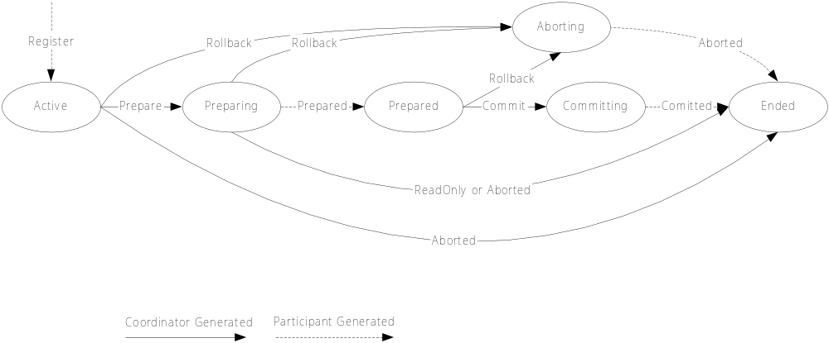
Figure 1-11 Two-Phase Commit State Transitions
Once the 2PC protocol has finished, the Completion or CompletionWithAck protocol that originally began the termination of the transaction can complete, and inform the client application whether the transaction was committed or rolled back. Additionally, some services may have registered an interest in the completion of a transaction, and they will be informed via the OutcomeNotificatonProtocol.
Like the PhaseZero protocol, the OutcomeNotificatonProtocol is an optional protocol that some services will register for so that they can be informed when the transaction has completed, typically so that they can release resources (e.g., put a database connection back into the pool of connections).
Any registered OutcomeNotification participants are invoked after the transaction has terminated and are told the state in which the transaction completed (the coordinator sends either the Committed or Aborted message). Since the transaction has terminated, any failures of participants at this stage are ignored - OutcomeNotification is essentially a courtesy, and has no bearing on the outcome of the transaction.
Finally, after having gone through each of the stages in an AT, we can now see the intricate interweaving of individual protocols that goes to make up the AT as a whole in Figure 1-12.
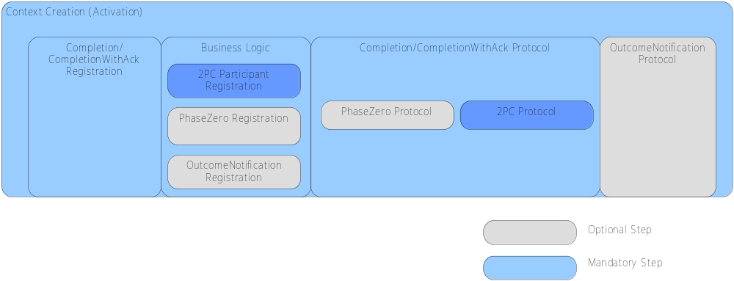
Figure 1-12 The AT Model

Business Activities (BA)
Most business-to-business applications require transactional support in order to guarantee consistent outcome and correct execution. These applications often involve long running computations, loosely coupled systems and components that do not share data, location, or administration and it is difficult to incorporate atomic transactions within such architectures. For example, an online bookshop may reserve books for an individual for a specific period of time, but if the individual does not purchase the books within that period they will be “put back onto the shelf” for others to buy. Furthermore, because it is not possible for anyone to have an infinite supply of stock, some online shops may appear to users to reserve items for them, but in fact may allow others to pre-empt that reservation (i.e., the same book may be “reserved” for multiple users concurrently); a user may subsequently find that the item is no longer available, or may have to be reordered specially for them.
A business activity or BA is designed specifically for these kinds of long-duration interactions, where exclusively locking resources is impossible or impractical. In this model services are requested to do work, and where those services have the ability to undo any work, they inform the BA such that if the BA later decides the cancel the work (i.e. if the business activity suffers a failure), it can instruct the service to execute its undo behavior. The key point for Business Activities is that how services do their work and provide compensation mechanisms is not the domain of the WS-Transaction specification, but an implementation decision for the service provider.
The WS-Transaction Business Activity simply defines a protocol for Web services-based applications to enable existing business processing and workflow systems to wrap their proprietary mechanisms and interoperate across implementations and business boundaries.
A business activity may be partitioned into scopes, where a scope is a business task or unit of work using a collection of Web services. Such scopes can be nested to arbitrary degrees, forming parent and child relationships, where a parent scope has the ability to select which child tasks are to be included in the overall outcome protocol for a specific business activity, and so clearly non-atomic outcomes are possible. In a similar manner to traditional nested transactions, if a child task experiences an error, it can be caught by the parent who may be able to compensate and continue processing.
When a child task completes it can either leave the business activity or signal to the parent that the work it has done can be compensated later. In the latter case, the compensation task may be called by the parent should it ultimately need to undo the work performed by the child.
Unlike the Atomic Transaction protocol model, where participants inform the coordinator of their state only when asked, a task within a business activity can specify its outcome to the parent directly without waiting for a request. This feature is useful when tasks fail such that the notification can be used by business activity exception handler to modify the goals and drive processing forward without having to meekly wait until the end of the transaction to admit to having failed – a well designed Business Activities should be proactive, if it is to be performant.
Underpinning all of this are three fundamental assumptions:
- All state transitions are reliably recorded, including application state and coordination metadata (the record of sent and received messages);
- All request messages are acknowledged, so that problems are detected as early as possible. This avoids executing unnecessary tasks and can also detect a problem earlier when rectifying it is simpler and less expensive;
- As with atomic transactions, a response is defined as a separate operation and not as the output of the request. Message input-output implementations will typically have timeouts that are too short for some business activity responses. If the response is not received after a timeout, it is resent. This is repeated until a response is received. The request receiver discards all but one identical request received.
As with atomic transactions, the business activity model has multiple protocols: BusinessAgreement and BusinessAgreementWithComplete. However, unlike the AT protocol which is driven from the coordinator down to participants, this protocol is driven much more from the participants upwards.
Under the BusinessAgreement protocol, a child activity is initially created in the Active state; if it finishes the work it was created to do and no more participation is required within the scope of the BA (such as when the activity operates on immutable data), then the child can unilaterally send an exited message to the parent. However, if the child task finishes and wishes to continue in the BA then it must be able to compensate for the work it has performed. In this case it sends a completed message to the parent and waits to receive the final outcome of the BA from the parent. This outcome will either be a close message, meaning the BA has completed successfully or a compensate message indicating that the parent activity requires that the child task reverse its work.
The BusinessAgreementWithComplete protocol is identical to the BusinessAgreement protocol with the exception that the child cannot autonomously decide to end its participation in the business activity, even if it can be compensated. Rather the child task relies upon the parent to inform it when the child has received all requests for it to perform work which the parent does this by sending the complete message to the child. The child then acts as it does in the BusinessAgreement protocol.
The crux of the BA model compared to the AT model is that is allows the participation of services that cannot or will not lock resources for extended periods.
While the full ACID semantics are not maintained by a BA, consistency can still be maintained through compensation, though the task of writing correct compensating actions (and thus overall system consistency) is delegated to the developers of the services under control of the BA. Such compensations may use backward error recovery, but will typically employ forward recovery.

Application Messages
Application messages are the requests and responses that are sent between parties that constitute the work of a business process. Any such messages are considered opaque by AXTS, and there is no mandatory message format, protocol binding, or encoding style so the developer is free to use any appropriate Web services protocol. In AXTS, the transaction context is propagated within the headers of SOAP messages.
Note that AXTS provides out-of-box support for service developers building WS-T-aware services on the JBoss platform. The provision of interceptors for automatic context handling at both client and service significantly simplifies the developer’s workload, allowing the developer to concentrate on writing the business logic without having to worry about the transactional infrastructure getting in the way. The interceptors simply add and remove context elements to application messages without altering the semantics of those messages. Any service which understands what to do with a WS-C context can use it, services which do not understand the context (those services that are not WS-C/T-aware) may ignore the context; the important point here is that AXTS manages contexts without user intervention.

WS-C/T Messages
Although the application or service developer rarely sees or is interested in the messages exchanged by the transactional infrastructure (the transaction manager and any participants), it is useful to understand what kinds of exchanges occur so that the underlying model can be fitted in to an overall architecture.
In AXTS, WS-C/T-specific messages are transported using SOAP messaging over HTTP . The types of messages that are propagated include instructions to perform standard transaction operations like begin, prepare.
Note that AXTS messages do not interfere in any way, shape, or form, with the application messages, and nor is there any requirement for an application to use the same transport as the transaction-specific messages. For example, it is quite reasonable for a client application to deliver its application-specific messages using SOAP RPC over SMTP even though under the covers the AXTS messages are delivered using a different mechanism.

Summary
AXTS is a coordination infrastructure designed to allow transactions to run between enterprises across the Internet. It is based on the WS-C/T specifications.
The preview release of AXTS only supports the Atomic Transaction model, but the final product release will support Business Activities. The use of the whole infrastructure is simple due to the fact that its functionality is exposed through a simple transactioning API. Furthermore AXTS provides all of the necessary plumbing to keep application and transactional aspects of an application separate, and to ensure that the transactionality of a system does not interfere with the functional aspects of the system itself.

Getting Started

Introduction
This chapter outlines the basic steps needed to get started with ArjunaXTS.

Installing the ArjunaXTS Software
For full instructions on how to install the AXTS software, please consult the installation guide, though in most cases the default options offered by the installer will suffice.

Basic Concepts
The basic building blocks of a AXTS-based application are the application itself, the Web services that the application consumes, the Transaction Manager, and the transaction participants which support those Web services. Though it is unlikely in a typical deployment that a single developer will be expected to support all of these roles, the concepts are presented here so that a global model can be visualized. It will often be the case that developers will produce services, or applications that consume services, whilst system administrators will run the transaction-management infrastructure.

The Transaction Manager
The transaction manager is a Web service which coordinates AXTS transactions. It is the only software component in AXTS that is meant to be run directly as a network service, rather than to support end-user code. The transaction manager runs as a document exchange Web service on AXIS.

Deploying the Transaction Manager
The AXTS Transaction Manager component consists of a number of .jar files containing the application’s class files, plus Web service and Web application (.wsr and .war) files which expose the necessary services. Programmers will typically include all these components in their application .ear file during application development, simplifying deployment of the transaction infrastructure. For production usage the Transaction Manager may be installed as an application in its own right, allowing for centralized configuration and management at the server level, independent of specific applications. The demonstration application shipped with AXTS provides a sample deployment descriptor illustrating how the Transaction Manager components can be included in an application.
Early access versions of AXTS bind key components to fixed names in the server’s JNDI namespace. Therefore, problems may arise if multiple application using AXTS are deployed to the same server concurrently. If you wish to deploy several transactional applications in the same server, the Transaction Manger must be deployed as a separate application and not embedded within the deployment of individual applications.
The module ArjunaXTS-EA-Deploy has been provided to assist in the configuration and deployment of a stand-alone transaction manager. In order to use this, you must:
- installed ArjunaXTS 1.0.
- have a separate JBoss installation for the coordinator.
- install ant 1.4 or later.
Note, it is important that a separate JBoss installation be used from the one that clients and services are deployed into since otherwise conflicts may occur between the various AXTS components.
You must then edit the build.xml included with ArjunaXTS-EA-Deploy to point to the JBoss installation where the transaction coordinator will be deployed. The files ws-c_axis_web-app.xml and ws-t_axis_web-app.xml in the dd directory of ArjunaXTS-EA-Deploy are the deployment descriptors for the WS-C and WS-T war files and need to be edited so that the URLs within them are correct for the coordinator’s deployment.
Once the deployment descriptors have been updated, simply run ant and this will create and deploy a new coordinator EAR file into the correct JBoss installation.
Now all you need to do is point your client at the required coordinator. To do this, edit the wstx.xml file in the client’s JBoss deployment and add:
<property name="com.arjuna.mw.wst.at.coordinatorURL"
value="http://localhost:8080/jboss-net/services/ActivationCoordinator"/>
Replace the value component with whichever URL you put in the corresponding WS-C deployment descriptor.

Configuring the Transaction Manager
The Transaction Manager and related infrastructure are configured by means of properties files: wscf.xml, wst.xml and wstx.xml. On the JBoss platform these files should be deployed to the conf directory of the server. For the most part the default values in these files need not be altered. However, two values MUST be changed in order for the Transaction Manger to run. The com.hp.mw.ts.arjuna.objectstore.objectStoreDir property determines the location of the persistent store used to record transaction state. The default value of C:/temp/ObjectStore should be changed to a value appropriate to your system. For production environments this directory should reside on fault tolerant media such as a RAID array. The second critical property is ArjunaCore_LicenceKey The value of this property should be set to the licence string provided to you by Arjuna Technologies. If you do not have a licence key, please email support@arjuna.com or visit our web site to obtain a free, time limited evaluation licence.
Please note that AXTS is highly modular. In order to allow flexible deployment of individual components, the same property values are sometimes required to appear in more than one configuration file. For the majority of configurations, you should maintain consistent values for properties that are defined in more than one file.

Deployment descriptors
In general, it should not be necessary to change the contents of the various deployment descriptors used by AXTS. However, if you do need to modify them they are all included in the ArjunaXTS-EA-Deploy module.
Not all AXTS components have ready access to the information in the deployment descriptors. Therefore, if you modify the JNDI names used by any of the WS-C or WS-T deployment descriptors you may need to inform other AXTS components at runtime. This can be accomplished by setting an appropriate property in the wstx.xml configuration file.
The following table shows the default JNDI name used by the deployment descriptors and the corresponding property to set if the default value is changed.
JNDI Name | Property
activationrequester | com.arjuna.mw.wst.at.activationrequester
activationcoordinator | com.arjuna.mw.wst.at.activationcoordinator
completionparticipant | com.arjuna.mw.wst.at.completionparticipant
completionwithackparticipant | com.arjuna.mw.wst.at.completionwithackparticipant
registrationrequester | com.arjuna.mw.wst.at.registrationrequester
twopcdispatcher | com.arjuna.mw.wst.at.twopcdispatcher
twopcparticipant | com.arjuna.mw.wst.at.twopcparticipant
phasezerodispatcher | com.arjuna.mw.wst.at.phasezerodispatcher
phasezeroparticipant | com.arjuna.mw.wst.at.phasezeroparticipant
outcomenotificationdispatcher | com.arjuna.mw.wst.at.outcomenotificationdispatcher
outcomenotificationparticipant | com.arjuna.mw.wst.at.outcomenotificationparticipant
Table 2: Deployment descriptor values and properties.

Creating and Deploying Participants
A participant is a software entity which is driven by the transaction manager on behalf of a Web service. The creation of participants is non-trivial since they ultimately reflect the state of a Web service’s back-end processing facilities which is a function of an enterprise’s own IT infrastructure. The most that can be said about the implementation of a participant without getting into detail about the back-end systems it represents, or the details of the underlying transaction protocol is that implementations must implement one of the following interfaces, depending upon the protocol it will participant within: com.arjuna.wst.PhaseZeroParticipant, com.arjuna.wst.TwoPCParticipant, or com.arjuna.wst.OutcomeNotificationParticipant.
A full description of ArjunaXTS’s participant features is provided in the participant guide starting on page 39.

Creating Client Applications
There are two aspects to a client application using AXTS. The first is the transaction declaration aspects and the second is the business logic that the client application performs. The transaction declaration aspects are taken care of automatically with AXTS’s client API. This API provides simple transaction directives like begin, commit, and rollback which the client application can use to initialize, manage, and terminate transactions. Under the covers, this API invokes (via SOAP) operations on the transaction manager.
When the client application performs invocations on business logic Web services, then AXTS does not dictate an API for that purpose. However, there is a requirement that whatever API is chosen, the AXTS context be inserted onto outgoing messages, and extracted and associated with the current thread for incoming messages. To make the user’s life easier, the AXTS software comes complete with two “filters” which can perform the task automatically. These filters are designed to work with the Apache AXIS client library which is freely downloadable from http://xml.apache.org/axis .
If the user chooses to use a different SOAP client infrastructure, then the onus to perform client-side header processing rests with them. AXTS does not provide client-side infrastructure for anything other than AXIS for this release.
In order to register the AXIS client-side context handlers with the AXIS engine, the developer must ensure that a client configuration file exists in the directory where the AXIS-based client is executed from (the current working directory). This file should be called client-config.wsdd and should contain XML in accordance with Figure 2-13 below.
<?xml version="1.0" ?>
<deployment xmlns="http://xml.apache.org/axis/wsdd/" xmlns:java="http://xml.apache.org/axis/wsdd/providers/java">
<globalConfiguration>
<parameter name="sendXsiTypes" value="true"/>
<parameter name="sendMultiRefs" value="true"/>
<parameter name="sendXMLDeclaration" value="true"/>
<requestFlow>
<handler type="java:com.arjuna.mw.wst.client.OutgoingContextHandler"/>
</requestFlow>
<responseFlow>
<handler type="java:com.arjuna.mw.wst.client.IncomingContextHandler"/>
</responseFlow>
</globalConfiguration>
<transport name="http" pivot="java:org.apache.axis.transport.http.HTTPSender"/>
<transport name="local" pivot="java:org.apache.axis.transport.local.LocalSender"/>
</deployment>
Figure 2-13 The client-config.wsdd File
Again, the developer should not be alarmed at the contents of the client-config.wsdd file. It merely instructs the AXIS engine to process outgoing and incoming messages with the AXTS client-side header processing classes.

Hints and tips
If you want to create multiple JBoss deploys on the same machine, then you may wish to look at http://www.yorku.ca/dkha/jboss/docs/MultipleInstances.htm for information on what is required.

Summary
This chapter has provided a high-level overview of how to use each of the major software components of AXTS. The AXTS transaction manager is the hub of the architecture and is the only piece of software that users’ software does not bind to directly. AXTS provides header processing infrastructure for dealing with AXTS contexts for both users’ client applications and Web services. For developing transaction participants, AXTS provides a simple interface plus the necessary document handling code.
This chapter is meant as an overview only, and is unlikely to answer questions on more difficult and subtle aspects. For fuller explanations of the components, please refer to the appropriate chapter in the user documentation.

Transactional Web Services

Introduction
This chapter describes how to provide transactional support for new and existing Web services using the service-side facilities of ArjunaXTS. It shows how new services can be made transactional with no additional programming, and how existing services can be made WS-T transaction-aware in a non-invasive fashion.

A Transactional Web Service
A Web service is a business-level entity. It encapsulates application logic needed to perform some domain-specific task, or is designed to delegate to a back-end system which executes that logic. Given it is part of application code, such non-functional requirements as transactionality should not impinge on its construction.
To support this notion, ArjunaXTS provides a suite of components designed to work at the SOAP stack level, which deal with transactional matters on behalf of a Web service without requiring any changes to that service. In ArjunaXTS two context handling components are registered with the SOAP server and deal with context management on behalf of the service without the service having to worry about context propagation issues itself. This is shown in Figure 3-14.
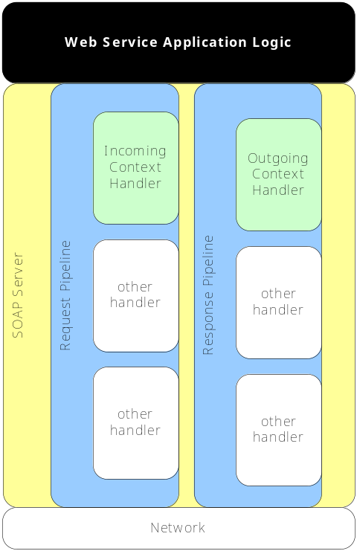
Figure 3-14 Context Handlers Registered with the SOAP Server
The details of the context management that the context processor perform is unimportant to the Web service application logic, and is orthogonal to any work performed by any other protocol-specific context handlers too. However back-end systems which the Web service application logic uses (such as databases) are often interested in the front-end transaction context such that any operations invoked within its scope can be mapped onto a back-end transaction context. This is typically achieved at the back-end by wrapping a database driver in a veneer which implements both the interface of the original driver and hooks into the service-side API to access the transaction context details. The general architecture for this pattern is shown in Figure 3-15.
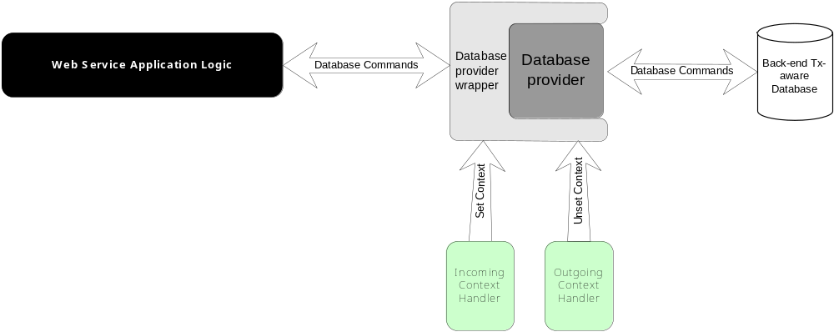
Figure 3-15 General Pattern for Back-End Integration, Service Side
The missing element from this is the commit protocol which finally allows back-end work to be made durable or not at the end of a transaction. This is covered in the participant chapter where the participant/back-end relation is explored further.

Participants

Introduction
This chapter describes the function of participants in AXTS transactions and how to build and deploy participants for use in your transactional Web services.

The Participant: An Overview
The participant is the entity that performs work pertaining to transaction management on behalf of the business services involved in an application. The Web service (e.g., a theatre booking system) contains some business logic for reserving a seat, enquiring availability etc, but it will need to be supported by something that maintains information in a durable manner. Typically this will be a database, but it could be a file system, NVRAM, etc. Now, although the service may talk to the back-end database directly, it cannot commit or undo any changes it (the services) makes, since these are ultimately under the control of the transaction that scoped the work. In order for the transaction to be able to exercise this control, it must have some contact with the database. In AXTS this is accomplished by the participant, and the role played by the participant between the transaction and back-end transaction processing infrastructure is shown in Figure 4-16.
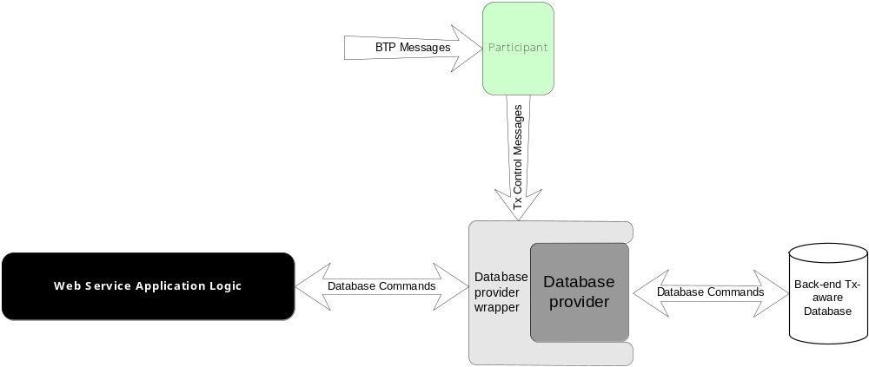
Figure 4-16 Transactions, Participants, and Back-End Transaction Control
Each participant in AXTS is an instance of one of the following interfaces.

PhaseZeroParticipant
This participant supports the WS-T PhaseZero protocol with the following signatures, as per the com.arjuna.wst.PhaseZeroParticipant interface:
- phaseZero: the transaction that the participant was enlisted with is about to complete. The participant may flush cached state (for example) to be managed by a recoverable service prior to the two-phase commit protocol beginning.
- error: the coordinator informs the participant than an error has occurred.

TwoPCParticipant
This participant supports the WS-T 2PC protocol with the following signatures, as per the com.arjuna.wst.TwoPCParticipant interface:
- prepare: the participant should perform any work necessary to allow it to either commit or rollback the work performed by the Web service under the scope of the transaction. The implementation is free to do whatever it needs to in order to fulfill the implicit contract between it and the coordinator. The participant is expected to indicate whether it can prepare or not by returning an instance of the com.arjuna.wst.Vote. Values are: ReadOnly, indicating the participant does not need to be informed of the transaction outcome as no state updates were made; Prepared, indicating the participant is prepared to commit or rollback depending on the final transaction outcome, and it has made sufficient state updates persistent to accomplish this; and Aborted, indicating the participant has aborted and the transaction should also attempt to do so.
- commit: the participant should make permanent the work that it controls. What it does will depend upon its implementation, e.g., commit the reservation of the theatre ticket. The participant will then return an indication of whether or not it succeeded.
- rollback: the participant should undo the work that it controls. The participant will then return an indication of whether or not it succeeded.
- commitOnePhase: if there is only a single TwoPCParticipant registered with the transaction, then the coordinator can optimize the protocol and simply tell the participant to commit: there is no need for a preparatory phase since consensus is implicit.
- unknown: during recovery the participant can enquire as to the status of the transaction it was registered with. If that transaction is no longer available (has rolled back) then this operation will be invoked by the coordination service.
- error: during recovery the participant can enquire as to the status of the transaction it was registered with. If an error occurs (e.g., the transaction service is unavailable) then this operation will be invoked.

OutcomeNotificationParticipant
This participant supports the WS-T 2PC protocol with the following signatures, as per the com.arjuna.wst.OutcomeNotificationParticipant interface:
- committed: the transaction committed.
- aborted: the transaction rolled back.
- unknown: if the participant enquires as to the status of the transaction it was registered with and that transaction is no longer available (has rolled back) then this operation will be invoked by the coordination service.
- error: if the participant enquired as to the status of the transaction it was registered with and an error occurs (e.g., the transaction service is unavailable) then this operation will be invoked.

Participant Creation and Deployment
As we have seen, the participant provides the plumbing that drives the transactional aspects of the service. This section discusses the specifics of Participant programming and usage.

Implementing Participants
Implementing a participant is, in theory, a relatively straightforward task, though depending on the complexity of the transactional infrastructure that the participant is to manage, the actual size and complexity of a participant will vary. The participant interfaces can be found under com.arjuna.wst. Your implementation must implement one of these interfaces.

Deploying Participants
In order to allow Participants to be located remote from the Transaction Manager, AXTS includes transparent message routing functionality. The Participant classes are not exposed directly as web services, but rather registered with a web service which receives messages from the Transaction Manager and maps them to appropriate method invocations on the relevant Participant instance. Transactional web services will typically enroll a new Participant instance of the desired type for each new transaction. A unique identifier must be provided at enrolment time and will be used to map transaction protocol messages to the appropriate participant instance. Note that Participant method invocations do not occur in a specific transaction context. Therefore, if your Participant implementation requires knowledge of the transaction context (e.g. to look up state information in a persistent store) then you should provide this to the Participant instance, typically as an argument to the constructor function. Sample Participant implementations and usage can be found in the demonstration application included with AXTS.
Any application code which creates and enrolls Participants must be deployed along with the parts of AXTS necessary for receiving and processing incoming messages from the Transaction Manager. This typically means including the appropriate AXTS .jar, .wsr and .war files in your application. If you are deploying your application only a server which does not already contain a Transaction Manger installation, you will also need to deploy the AXTS configuration files.
Note that in early access releases of the AXTS product, the Transaction Manager and participant management functions are not provided as separable components. Configuration and deployment of the participant infrastructure is therefore as in the Transaction Manger section above. More flexible deployment of the AXTS components will be available in the final release.

The ArjunaXTS API

Introduction
This chapter shows how to use the AXTS API. This is of use both at the client-side where applications consume transactional Web services, and at the service/participant side where transactions need to be coordinated with back-end systems.

AXTS API
The following classes and interfaces are located within the com.arjuna.wst or com.arjuna.mw.wst packages and sub-packages.

Vote
During the two-phase commit protocol, a participant will be asked to vote on whether or not it can prepare to confirm the work that it controls. It must return one of the following subtypes of com.arjuna.wst.Vote:
- Prepared: the participant indicates that it can prepare if asked to by the coordinator. It will not have committed at this stage however, since it does not know what the final outcome will be.
- Aborted: the participant indicates that it cannot prepare and has in fact rolled back. The participant should not expect to get a second phase message.
- ReadOnly: the participant indicates that the work it controls has not made any changes to state that require it to be informed of the final outcome of the transaction. Essentially the participant is resigning from the transaction.
Thus a possible implementation of a 2PC participant’s prepare method may resemble the following:
public Vote prepare () throws WrongStateException, SystemException
{
// Some participant logic here

if(/* some condition based on the outcome of the business logic */)
{
// Vote to confirm
return new com.arjuna.wst.Prepared();
}
else if(/*some other condition based on the outcome of the business logic*/)
{
// Resign
return new com.arjuna.wst.ReadOnly();
}
else
{
// Vote to cancel
return new com.arjuna.wst.Aborted();
}
}
Figure 5-17 API Example Showing Participant Voting

The transaction context
A transaction is typically represented by some unique identifier and a reference to the coordinator which manages the transaction, e.g., a URL. ArjunaXTS allows transactions to be nested such that a transaction hierarchy (tree) may be formed. Thus, a transaction context may be a set of transactions, with the top-most transaction the root parent (superior).

TxContext
com.arjuna.mw.wst.TxContext is an opaque representation of a transaction context.
- valid: this indicates whether or not the contents are valid.
- equals: can be used to compare two instances.

UserTransaction
The com.arjuna.wst.UserTransaction is the class that most users (e.g., clients and services) will see. This isolates them from the underlying protocol-specific aspects of the Arjuna-XST implementation. Importantly, a UserTransaction does not represent a specific transaction, but rather is responsible for providing access to an implicit per-thread transaction context; it is similar to the UserTransaction in the JTA specification. Therefore, all of the UserTransaction methods implicitly act on the current thread of control.
A new transaction is begun and associated with the invoking thread by using the begin method. If there is already a transaction associated with the thread then the WrongStateException exception is thrown. Upon success, this operation associates the newly created transaction with the current thread.
The transaction is committed by the commit method. This will execute the PhaseZero, 2PC and OutcomeNotification protocols prior to returning. If there is no transaction associated with the invoking thread then UnknownTransactionException is thrown. If the transaction ultimately rolls back then the TransactionRolledBackException is thrown. When complete, this operation disassociates the transaction from the current thread such that it becomes associated with no transaction.
The rollback operation will terminate the transaction and return normally if it succeeded, while throwing an appropriate exception if it didn’t. If there is no transaction associated with the invoking thread then UnknownTransactionException is thrown.

UserTransactionFactory
UserTransactions are obtained from a UserTransactionFactory.

TransactionManager
The TransactionManager interface represents the service/container/participant’s (service-side users) typical way in which to interact with the underlying transaction service implementation. As with UserTransaction a TransactionManager does not represent a specific transaction, but rather is responsible for providing access to an implicit per-thread transaction context.
A thread of control may require periods of non-transactionality so that it may perform work that is not associated with a specific transaction. In order to do this it is necessary to disassociate the thread from any transactions. The suspend method accomplishes this, returning a TxContext instance, which is a handle on the transaction. The thread is then no longer associated with any transaction.
The resume method can be used to (re-)associate a thread with a transaction(s) via its TxContext. Prior to association, the thread is disassociated with any transaction(s) with which it may be currently associated. If the TxContext is null, then the thread is associated with no transaction. The UnknownTransactionException exception is thrown if the transaction that the TxContext refers to is invalid in the scope of the invoking thread.
The currentTransaction method returns the TxContext for the current transaction, or null if there is none. Unlike suspend, this method does not disassociate the current thread from the transaction(s). This can be used to enable multiple threads to execute within the scope of the same transaction.
In order to register and resign participants with a transaction, the container or participant must use:
- enlistForPhaseZero: enlist the specified participant with current transaction such that it will participate in the PhaseZero protocol; a unique identifier for the participant is also required. If there is no transaction associated with the invoking thread then the UnknownTransactionException exception is thrown. If the coordinator already has a participant enrolled with the same identifier, then AlreadyRegisteredException will be thrown. If the transaction is not in a state where participants can be enrolled (e.g., it is terminating) then WrongStateException will be thrown.
- enlistForTwoPhase: enlist the specified participant with current transaction such that it will participate in the 2PC protocol; a unique identifier for the participant is also required. If there is no transaction associated with the invoking thread then the UnknownTransactionException exception is thrown. If the coordinator already has a participant enrolled with the same identifier, then AlreadyRegisteredException will be thrown. If the transaction is not in a state where participants can be enrolled (e.g., it is terminating) then WrongStateException will be thrown.
- enlistForOutcomeNotification: enlist the specified participant with current transaction such that it will participate in the OutcomeNotification protocol; a unique identifier for the participant is also required. If there is no transaction associated with the invoking thread then the UnknownTransactionException exception is thrown. If the coordinator already has a participant enrolled with the same identifier, then AlreadyRegisteredException will be thrown. If the transaction is not in a state where participants can be enrolled (e.g., it is terminating) then WrongStateException will be thrown.

TransactionFactory
TransactionManagers are obtained from a TransactionFactory.

AXTS can support ACID-like transactions with a type of transaction called an atom; however, AXTS also allows you to aggregate multiple ACID transactions into a non-ACID transaction, known as a Cohesion. Non-ACID transactions permit a number of participants in a transaction to fail according to the dictates of some business logic, but the transaction itself is still able to reach a successful outcome.
Redrawn from the WS-Transaction specification, see http://msdn.microsoft.com/library/default.asp?url=/library/en-us/dnglobspec/html/ws-transaction.asp
The tech. preview release of ArjunaXTS does not support Business Activities.
Future versions of AXTS will support other SOAP platforms.

